# The Art of Faulkner’s Narrative Technique

## Introduction

In his 1917 essay “Art as Technique,” the Russian formalist scholar, Viktor Shklovsky, made what would be one of the most influential distinctions in the study of narrative: story vs. plot. He posited that that authors took the rough materials of a story and shaped them in a particular way into a plot. The story or fabula is the sequence of events as they occurred and the plot is the sequence in which the author reveals those events (cite). Based on this distinction, an elaborate vocabulary for describing narrative became available, most notably analepsis(flashback) and prolepsis (flashforward). Over a century old, Shklovsky’s distinction has not remained unchallenged, and various critics at various times have questioned the possibility of separating a narrative or story from how it is told (discourse) (cite).

## Creating the Chronologies

Those criticisms notwithstanding, the *Digital Yoknapatawpha* project, has undertaken the task of encoding the chronological order of an event along with its sequence in the text. The process for doing this is not unproblematic. For example, in the *Sound and the Fury* it is easy to order the sequence of the chapters because Faulkner gives their dates: “April Seventh, 1928”, “June Second, 1910”, “April Sixth, 1928”, and “April Eighth, 1928.” Clearly, the chronological sequence of chapters is chapter 2, 3, 1, and 4. Yet, anyone who has read the *Sound and the Fury* knows that ordering the sequence of events within chapters is part of the challenge of the work, and, indeed, also its art.

For this reason, Faulkner’s chronologies have become somewhat of a bailiwick for scholars, and many have tried to establish the chronology of either Yoknapatawpha County in general or specific stories (cite). The *DY* editors have relied on many previous studies to establish the chronological order for *all* of Faulkner’s texts. Still, even with the help of this robust corpus, sequencing the events in a story is a very involved process, and there are many interpretive decisions that the *DY* collaborators had to make in order to establish these chronologies. While it makes no sense to enumerate each specific issue, suffice it to say that these were related to the use of relative time. In Faulkner, and in most other narratives, time is not always specific, but can be relational. Concepts “before” “after” “, “a couple of years ago”, and “around the same time” all indicate the relative sequence of an event, but do not indicate its specific position on a timeline. For example, is the event that happened “a couple of years ago” “before” or “after” the event that happened “around the same time”? In some cases, deciding the order came down to what would be the most logically consistent sequence of events, something which, by the way, did not always trouble Faulkner (cite Mansion).

## Interpreting the Charts

### Linearity

In the charts, the time structure of the text has been mapped with the story on the y-axis (vertical) and the plot on the x-axis (horizontal). Moving from left to right on the x-axis is the sequence of events as told in the text by page number. Meanwhile, moving from bottom to top on the y-axis reveals when in the chronology that specific event occurs. With events lower down occurring before events higher up. In a chart where events are revealed in the order in which they occur the slope should be around forty-five degrees. In the chart below, “Raid”, most of the events occur in the order they are conveyed to the reader. There are a couple of moments where there are “dips”. These are moments when the text refers to an earlier event. This is commonly known as a flashback. On the whole though, the chart indicates a relatively linear sequence of events.

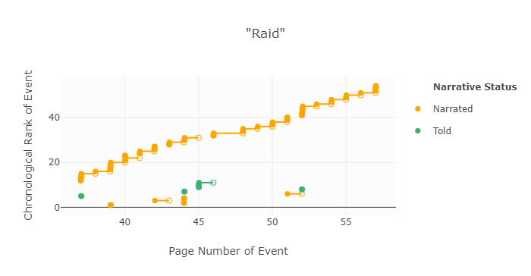

Part of Faulkner’s signature writing style are his experiments with time, and these are very visible in the charts from his more canonical works. In *The Sound and the Fury*, the chapters are “out of order”, but so are many of the events within the chapters. The scatter of points on this chart indicates a constant jump back and forth in time. Viewed from this perspective, it is possible to contrast “Raid” and *The Sound and the Fury* and conclude that the latter is less linear.

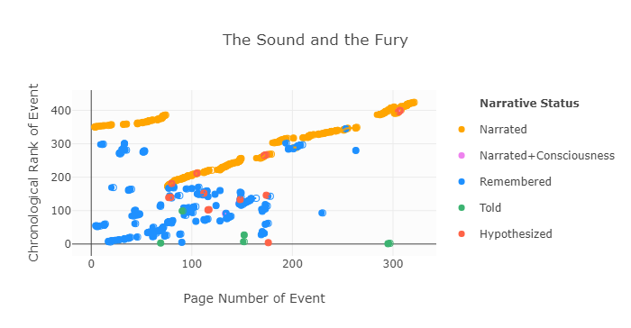

### Narrative Status

Along with the sequence of the event the *DY* collaborators also created a rubric for indicating *how* that event is conveyed to the reader. In some cases, there is a third person narrator, in other cases an event is remembered, as when Benjy and Quentin go about their respective days. At other times, events are told by characters in a text, something quite different yet again. A full overview of the differences can be found here(link). The usefulness of knowing narrative status is that it provides another window into understanding how Faulkner structures his narratives. In *Go Down*, *Moses* events are conveyed to the reader in through multiplicity of perspectives adding to the ambiguity of the narrative and the richness of its interpretation. 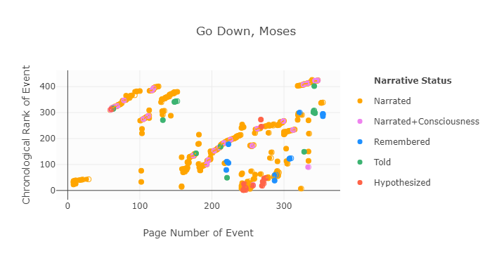

### Rank Order and Date Order

The most natural way to think of chronology is date order. It is one of the most common descriptors of someone’s life, a born date and death date. The sequence of dates between those rather definite book-ends is somewhat less definitive. People might remember the year or even month of an important life event, but they may not remember the day, or they may remember the day of the week, but not the calendar date. With the help of external sources, these sequences can sometimes be reconstructed. Much the same, the sequencing of historical events too relies on cross-referencing sources to establish a timeline, though such timelines also suffer from lacunae.

These problems are compounded when establishing a timeline for fictional narratives, since there usually are no external sources to reference. There is no way to pull up Quentin’s class schedule at Harvard to establish where he should have been on June 2nd and at what time! As such, the *DY* collaborators have inferred dates based on the sequence of events. Needless to say, it was not always possible to pin down one singular date for an event, and this is why an earliest possible start date and latest possible end date for an event were entered. Hence, an event that takes place during a year is given a range of year, unless any more information about the possible date is known. Ideally, all date ranges would be as narrow as possible, in reality this is not the case.

As date ranges are necessarily ambiguous, the rank order of events is also available for selection. The rank order sequences events as represented in the chronology, but does not take into consideration the narrative distance between them. In *The Sound and the Fury* the earliest event is the birth of Jesus, an event that happens some time before the narrative present of the text. On the rank order chart this is a small green dot right around page 300. On the date order chart this event is more apparent:

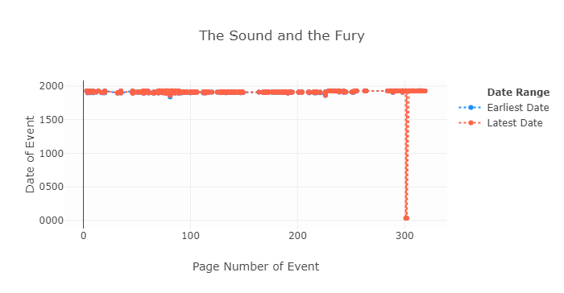

By default charts are graphed by Rank Order, though undoubtedly the date order graphs order equally interesting insights. In particular, they tend to highlight how the historical past is in tension with the narrative present. In some cases, the date range of a chart is very small, such as in “Centaur in Brass” where the narrative sequence is almost entirely in the narrative present with one prospective event in the future.

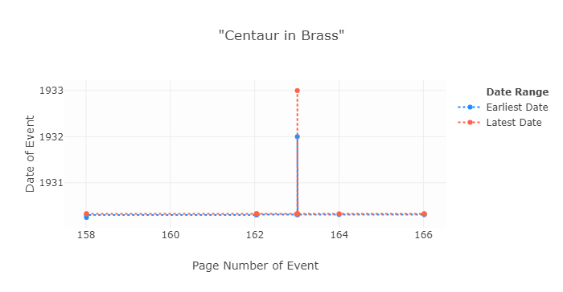

In other cases, the narrative jumps around in time in leaps and bounds, suggesting a positioning withing a larger historical time scale. For instance, *The Reivers* is told from the perspective of the 1960s and stretches as far back as the American Revolution, but is mostly situated at the turn of the 20th century.

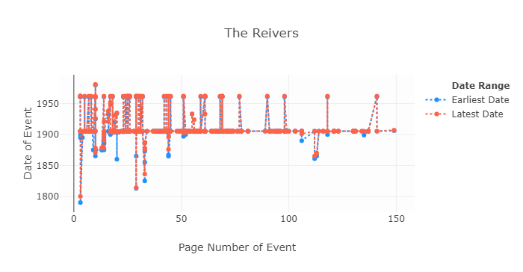

The chart very nicely underscores the subtitle of the novel, *A Reminiscence*, and demonstrates that the novel is as much about the events that transpire in the novel, as those events are viewed from a post-World War II perspective within a larger view of American history.